MASTER & SYLVANIA DRIVING SCHOOL
6725 West Central Avenue, Suite Q1
Toledo, Ohio 43617
419-841-4458
support@master-driving.com
Thank you for choosing Master & Sylvania Driving School for the 8 hours of behind-the-wheel instruction. To get started, please complete the online Training Agreement in its entirety, including both the parent and student signatures.
We must receive the following items before scheduling driving lessons:
• Signed Training Agreement (first page only)
• Payment in full
• Completed registration form
• Original 24-hour online course completion certificate
These items may be returned by mail, in person, or emailed to the address listed above.
Please keep the Student Behind-the-Wheel Training Reports with you.
If you do not live in Toledo, provide these forms to the instructor at the first driving lesson.
If you do live in Toledo, include these forms with your paperwork submission.
Payment Information:
Checks should be made payable to BKH Inc. and included with your paperwork.
Credit card payments are subject to a 4% processing fee. Please call the office to provide credit card information.
Scheduling & Lessons:
Students who live in the area will be picked up for their driving lessons. We offer private lessons, seven days a week. Students must have their temporary permit with them for every lesson.
Once all required paperwork has been submitted, please call our office and select extension 13 to be placed in the scheduling queue.
Cancellations & Fees:
A minimum of 24 hours’ notice is required to cancel or reschedule a lesson. Failure to provide notice will result in a $20 per hour charge.
For weekend lessons, the office must be notified by Friday at 6:00 p.m.
Certificate Issuance:
Certificates are reviewed after the final lesson and emailed within 1–2 business days. The printed certificate is required on exam day.
Office Hours:
Monday through Friday, 9:00 a.m. to 6:00 p.m.
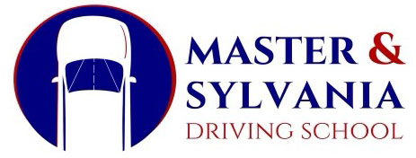
Thank you for choosing Master & Sylvania Driving School.

